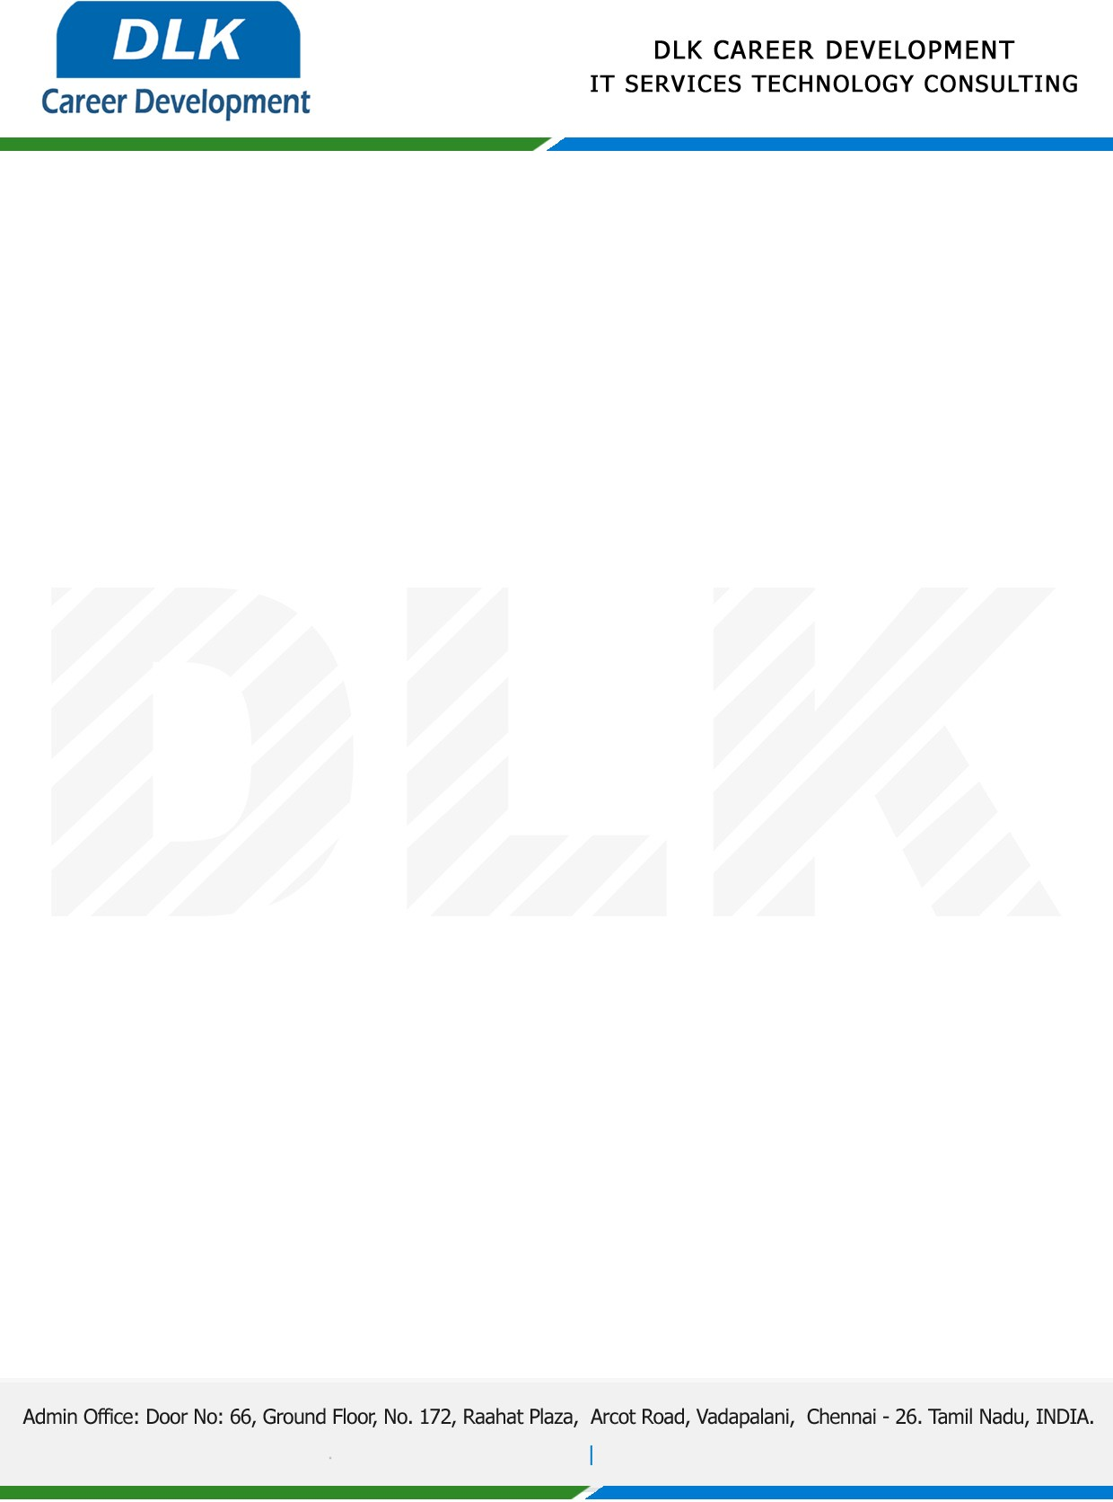

Date: 24 /December / 2022

**To**

Department of BCA(Computer Application) [,](https://www.cseindia.org/)

Head of Department,

S.I.V.E.T College, Chennai - 600073.

**Sub: Letter of Project Acceptance**

This is to certify that **MR AKASH R (REG NO: 212000056)** final year student of has accepted the Project Work duration from **28th December 2022** to **10th March 2023** under the domain **“Java”.** During the Project, all information and data collected from you should be kept confidential.

**Topic:** A Proof-of-Concept of Farmer-to-Consumer Food Products Traceability for Local Communities.

We appreciate your interest in **DLK CAREER DEVELOPMENT**

